Create Node-RED Service

|  |  |
| --- | --- |
| **Team ID** | **PNTIBMCL12** |
| **Project Name** | **Project - IOT based safety gadget for**  **child safety monitoring and notification** |
| **Maximum Marks** | **4 Marks** |

Aim: To create a web application create a Node-RED service. Steps followed:

* Navigated to the App creation page

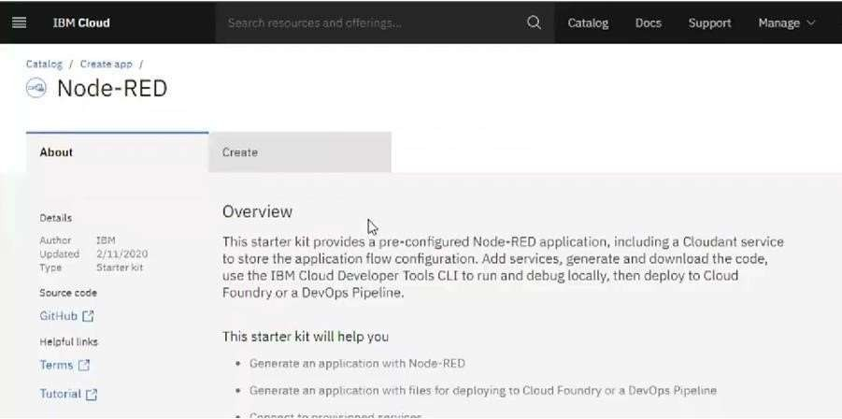

* Entered project details and clicked on create

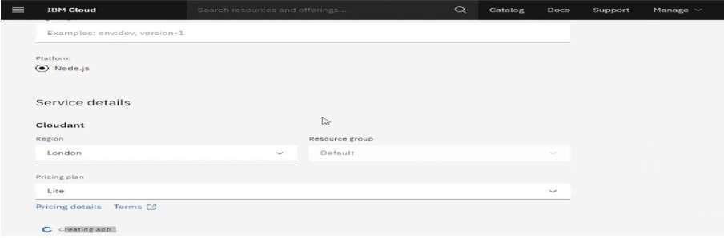

* Clicking on the “Deploy your App” Button

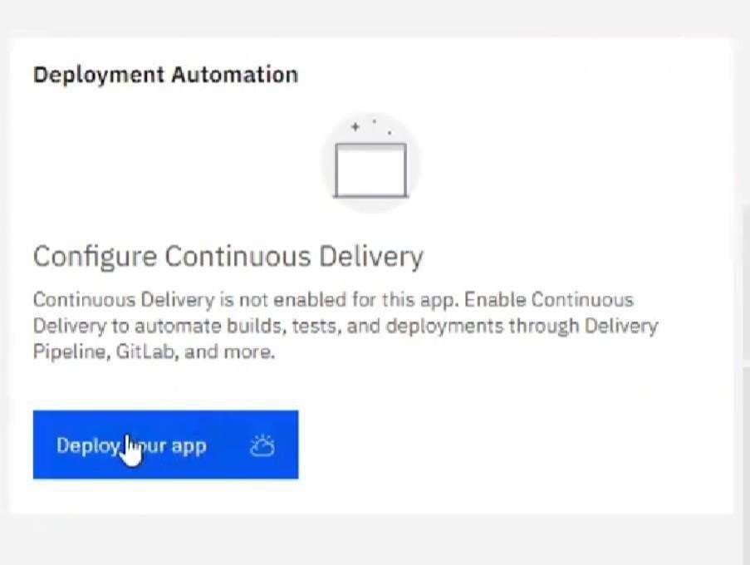

* Setting up the environment and deploying the app

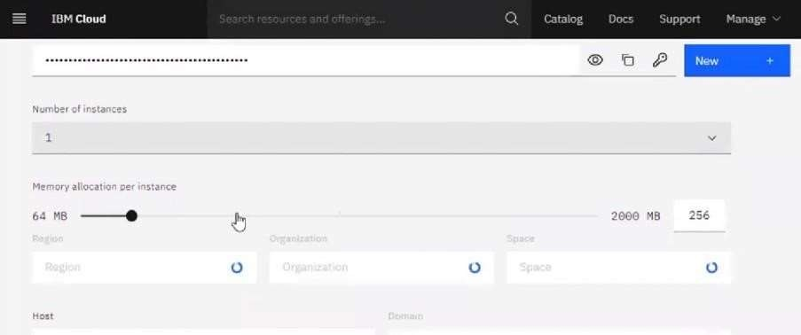

* Successfully deployed the app

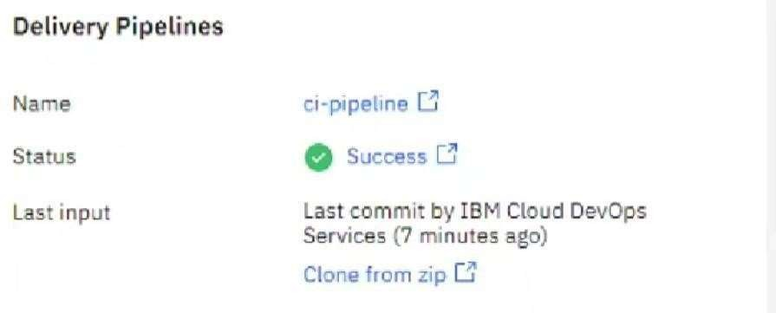

* Dragged and dropped components into the editor

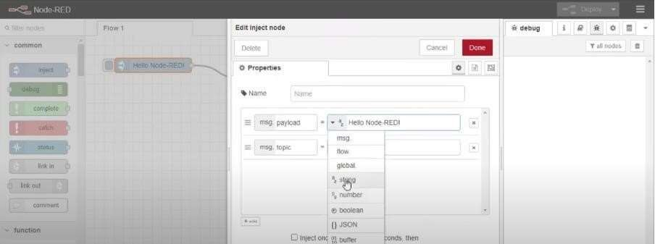

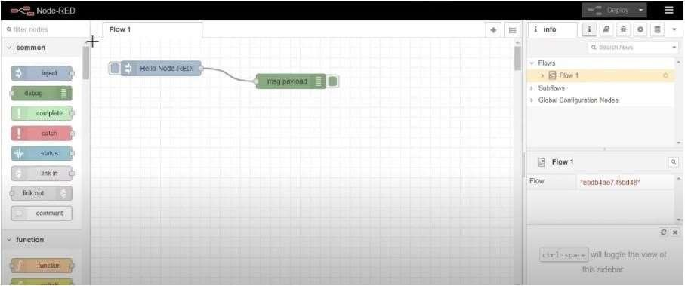

* Editing some values of the properties
* Successfully deployed the app

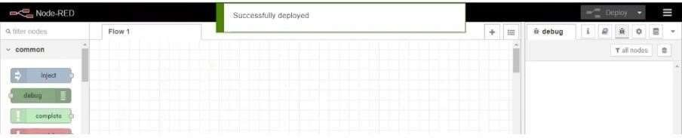

**Result: Successfully created a Node RED service on IBM Cloud**